**SOFTWARE REQUIREMENT SPECIFICATION DOCUMENT**

**ONLINE SHOPPING MART**

**By**

**AKHIL S**

**TABLE OF CONTENT**

|  |  |
| --- | --- |
| Abstract | 3 |
| Requirements | 3 |
| Flowchart | 5 |
| Use Case Diagram | 6 |
| Class Diagram | 7 |
| Sequence Diagram | 8 |
| Testcases | 9 |

**Abstract**

This Software Requirements Specification (SRS) document outlines the essential requirements and functionalities for the development of an Online Shopping Mart platform. The purpose of this document is to provide a comprehensive understanding of the system's capabilities. The Online Shopping Mart provides a platform for the sellers to sell their product and platform for the users to search for the products that they are in need of and buy those products using online transactions.

**Requirements**

**User Registration**

Users can register with the platform by providing necessary details.

**Login**

Users can login into the platform by entering the correct credentials.

**Product Viewing**

The users will have to view all the available products in the website.

**Product Management**

The seller should be able to add,edit,remove products in the website.

**Adding to Cart**

The user should be able to add the products that he/she wants to the cart.

**Placing Orders**

The user should be able to place orders.

**Making Payments**

The users should be able to make payments for the orders he/she has made.

**Flow Chart**

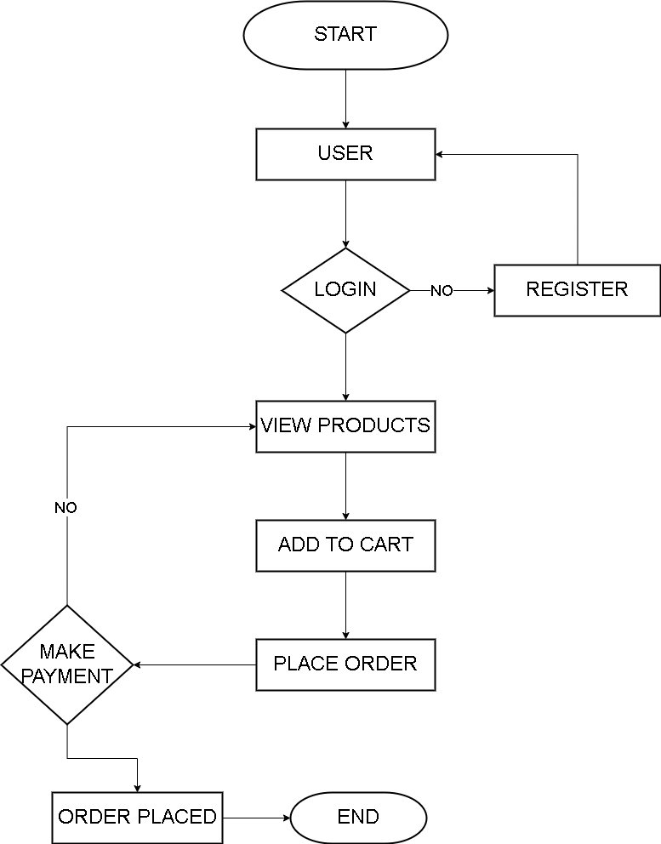

**Use Case Diagram**

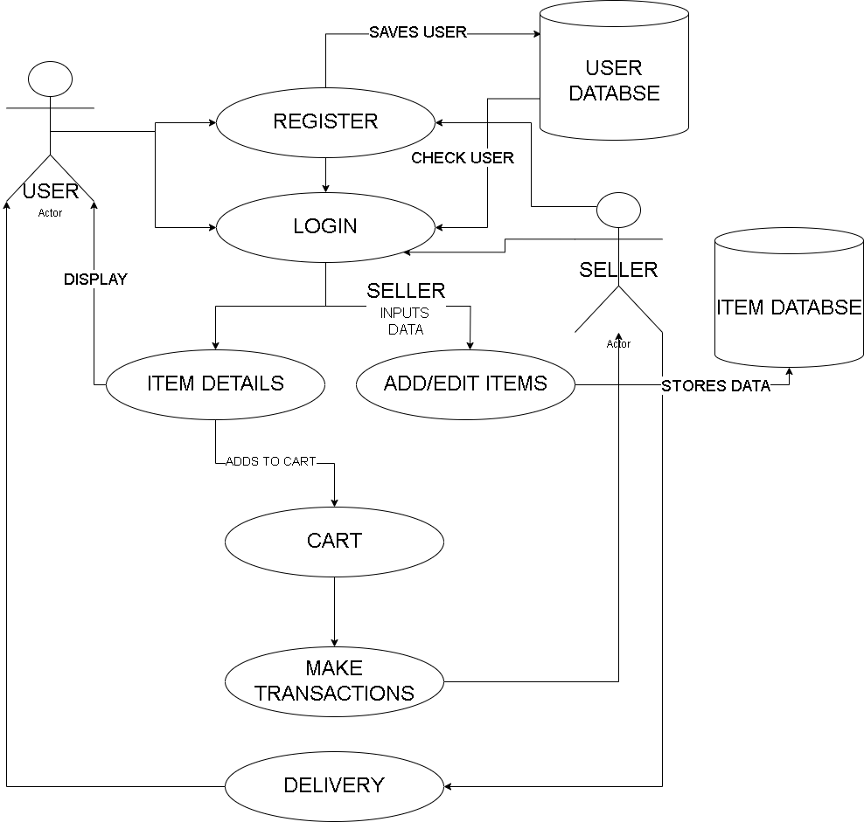

**Class Diagram**

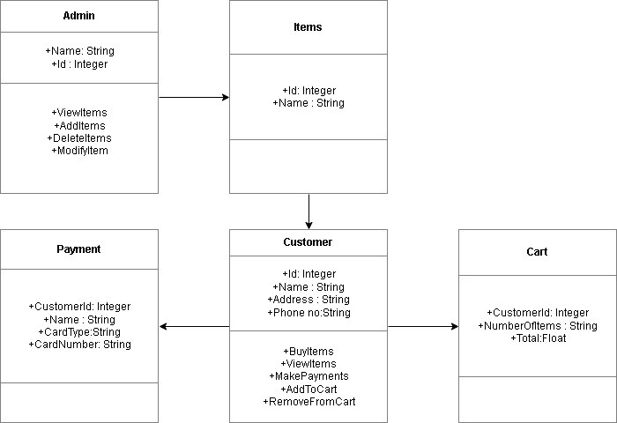

**Sequence Diagram**

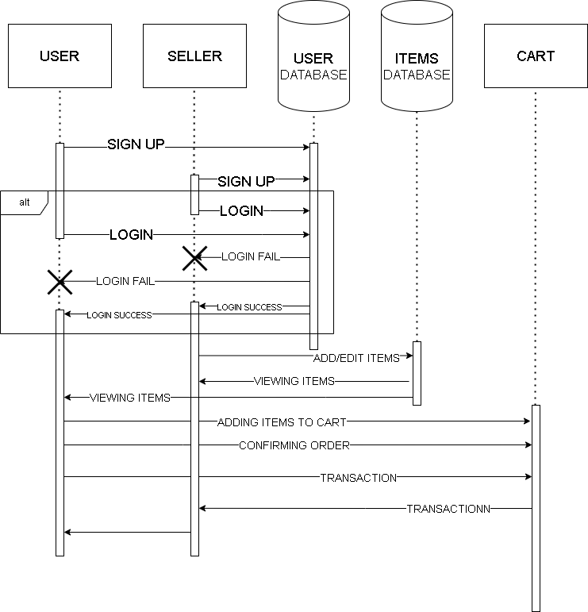

**Test Cases**

**Registration**

Verify that a new user can successfully register with valid credentials.

Ensure that registration fails if the username or email is already in use.

Validate that all mandatory fields are required during registration.

**Login**

Confirm that registered users can log in with valid credentials.

Ensure that login fails with incorrect username or password.

Check for session timeout functionality after a period of

inactivity.

**Users**

Perform the regression testing for both users’ buyers as well as retailers